|  |
| --- |
| sensor_1 sensor_2 sensor_3 sensor_4 sensor_5 sensor_6 sensor_7 |
| 0 1.125100 1.178124 0.493516 0.790880 -0.614278 1.347020 1.419515 |
| 1 -0.564641 3.638629 -1.522415 -1.541705 1.616697 4.781310 3.190292 |
| 2 0.516313 2.165426 -0.628486 -0.386923 0.492518 1.442381 1.332905 |
| 3 0.537282 0.966618 -0.115420 0.670755 -0.958516 0.871440 0.508186 |
| 4 0.278385 1.065828 -1.724917 -2.235667 0.715107 0.731249 -0.674119 |

|  |
| --- |
| sensor_8 sensor_9 sensor_10 failure_status timestamp |
| 0 1.357325 0.966041 -1.981139 1 2023-01-01 00:00:00 |
| 1 -0.890254 1.438826 -3.828748 0 2023-01-01 01:00:00 |
| 2 -1.958175 -0.348803 -1.804124 0 2023-01-01 02:00:00 |
| 3 -1.034471 -1.654176 -1.910503 1 2023-01-01 03:00:00 |
| 4 0.598330 -0.524283 1.047610 0 2023-01-01 04:00:00 |

Missing values before handling:

sensor_1 0

sensor_2 0

sensor_3 0

sensor_4 0

sensor_5 0

sensor_6 0

sensor_7 0

sensor_8 0

sensor_9 0

sensor_10 0

failure_status 0

timestamp 0

dtype: int64

Missing values after handling:

sensor_1 0

sensor_2 0

sensor_3 0

sensor_4 0

sensor_5 0

sensor_6 0

sensor_7 0

sensor_8 0

sensor_9 0

sensor_10 0

failure_status 0

timestamp 0

dtype: int64

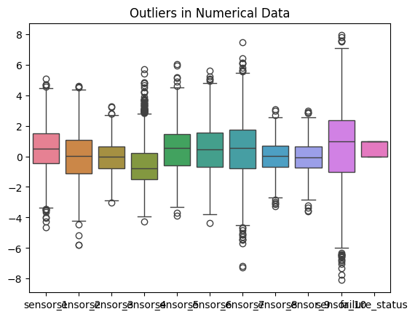

C:\Users\mabdu\AppData\Local\Temp\ipykernel_7792\1988624117.py:73: FutureWarning: DataFrame.fillna with 'method' is deprecated and will raise in a future version. Use obj.ffill() or obj.bfill() instead.

df.fillna(method='bfill', inplace=True)

Training set shape: (800, 33)

Testing set shape: (200, 33)

